The Parish Church of St Andrew
Orford with Longford

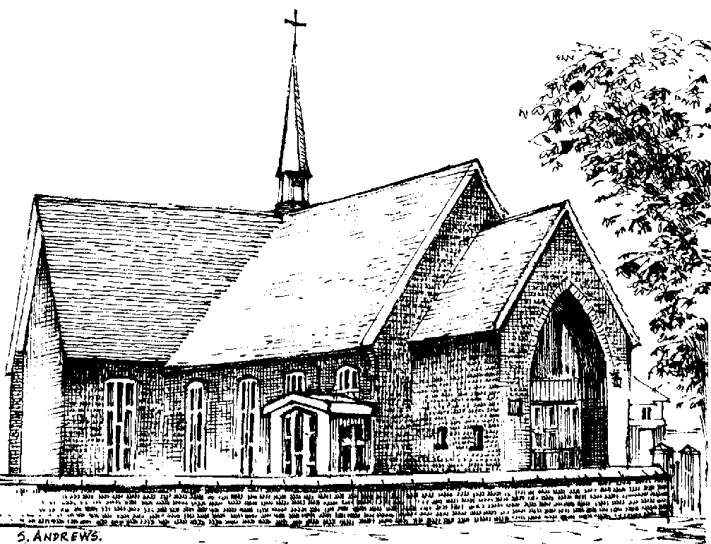

Arthur Roberts
1920 - 2010

Thursday 23rd December 2010

Order of Service

ALL STAND as the funeral procession enters church to the hymn tune “O valiant hearts”. Once the family are seated, please SIT.

Introduction

Priest: We meet in the name of Jesus Christ, who died and was raised to the glory of God the Father. Grace and mercy be with you.
All: Amen.

The priest introduces the service

Priest: Let us pray: (please remain seated)

Almighty God, you judge us with infinite mercy and justice, and love everything you have made. In your mercy turn the darkness of death into the dawn of new life, and the sorrow of parting into the joy of heaven; through our Saviour, Jesus Christ. Amen

All: Merciful Father, hear our prayers and comfort us; renew our trust in your Son, whom you raised from the dead; strengthen our faith that all who have died in the love of Christ will share in his resurrection; who lives and reigns with you, in the unity of the Holy Spirit, one God, now and for ever. Amen

The Ministry of the Word

Hymn: “Abide with me” (please stand)

Abide with me; fast falls the eventide:
the darkness deepens; Lord, with me abide:
when other helpers fail, and comforts flee,
help of the helpless, O abide with me.

Swift to its close ebbs out life's little day;
earth's joys grow dim, its glories pass away;
change and decay in all around I see:
O thou who changest not, abide with me.

I need thy presence every passing hour;
what but thy grace can foil the tempter's power?
Who like thyself my guide and stay can be?
Through cloud and sunshine, Lord, abide with me.

I fear no foe with thee at hand to bless;
ills have no weight, and tears no bitterness,
Where is death's sting? Where, grave, thy victory?
I triumph still, if thou abide with me.

Hold thou thy cross before my closing eyes;
shine through the gloom, and point me to the skies:
heaven's morning breaks, and earth's vain shadows flee;
in life, in death, O Lord, abide with me.

The Scriptural Reading (Revelation 21. 1-6)

The Address

Hymn: “The Old Rugged Cross” (please stand)

On a hill far away stood an old rugged cross,
The emblem of suff'ring and shame;
and I love that old cross where the dearest and best
For a world of lost sinners was slain.
So I'll cherish the old rugged cross
Till my trophies at last I lay down;
I will cling to the old rugged cross
And exchange it some day for a crown.

To the old rugged cross I will ever be true,
Its shame and reproach gladly bear;
Then He'll call me some day to my home far away,
Where his glory for ever I'll share.
So I'll cherish the old rugged cross

The Prayers:

Priest: God of mercy, Lord of life, you have made us in your image to reflect your truth and light: we give you thanks for Arthur, for the grace and mercy he received from you, for all that was good in his life, and especially for the memories we treasure today.

(after a short period of silence)

Lord, in your mercy
All: hear our prayer.

Priest: You promised eternal life to those who believe. Remember for good this your servant Arthur as we also remember him. Bring all who rest in Christ into the fullness of your kingdom where sins have been forgiven and death is no more.
Lord, in your mercy
All: hear our prayer.

Priest: Your mighty power brings joy out of grief and life out of death. Look in mercy on Arthur’s family and all who mourn at this time. Give them patient faith in times of darkness. Strengthen them with the knowledge of your love.
Lord, in your mercy
All: hear our prayer.

Priest: You are tender towards your children and your mercy is over all your works. Heal the memories of hurt and failure. Give us the wisdom and grace to use aright the time that is left to us here on earth, to turn to Christ and follow in his steps in the way that leads to everlasting life.
Lord, in your mercy
All: hear our prayer.
God of mercy, entrusting into your hands all that you have made and rejoicing in our communion with all your faithful people, we make our prayers through Jesus Christ our Saviour. Amen.

We remain kneeling to sing:

O Trinity of love and power,
our brethren shield in danger’s hour;
from rock and tempest, fire and foe,
protect them wheresoe’er they go:
thus evermore shall rise to thee
glad hymns of praise from land and sea.

Priest: Let us pray with confidence as our Saviour has taught us
All: Our Father, who art in heaven, hallowed be thy name; thy kingdom come; thy will be done; on earth as it is in heaven. Give us this day our daily bread. And forgive us our trespasses, as we forgive those who trespass against us. And lead us not into temptation; but deliver us from evil. For thine is the kingdom, the power and the glory, for ever and ever. Amen.

Hymn: “I vow to thee, my country” (please stand)

I vow to thee, my country, all earthly things above
entire and whole and perfect, the service of my love:
the love that asks no questions, the love that stands the test,
that lays upon the altar the dearest and the best;
the love that never falters, the love that pays the price,
the love that makes undaunted the final sacrifice.

And there’s another country I’ve heard of long ago,
most dear to them that love her, most great to them that know;
we may not count her armies, we may not see her King;
her fortress is a faithful heart, her pride is suffering;
and soul by soul and silently her shining bounds increase,
and her ways are ways of gentleness and all her paths are peace.
Commendation and Farewell [please remain standing]

Priest: Let us commend Arthur to the mercy of God our Maker and Redeemer.

The coffin is sprinkled with holy water taken from the font

Priest: With this water we call to mind Arthur’s baptism. As Christ went through the deep waters of death for us, so may he bring us to the fullness of resurrection life with Arthur and all the redeemed.

God our creator and redeemer, by your power Christ conquered death and entered into glory. Confident of his victory and claiming his promises, we entrust Arthur to your mercy in the name of Jesus our Lord, who died and is alive and reigns with you, now and for ever. Amen

All: Heavenly Father, in your Son Jesus Christ you have given us a true faith and a sure hope. Strengthen this faith and hope in us all our days, that we may live as those who believe in the communion of saints, the forgiveness of sins and the resurrection to eternal life; through Jesus Christ our Lord. Amen.

Priest: May God, in his infinite love and mercy, bring the whole Church, living and departed in the Lord Jesus, to a joyful resurrection, and the fulfilment of his eternal kingdom. Amen.

As the procession leaves church, God bless the Prince of Wales will be played. Please follow the family.

Acknowledgement: Common Worship: Pastoral Services, material from which is included in this service, is copyright © The Archbishops’ Council (2000)

